E-Commerce Admin Panel using Flask and MongoDB

# Introduction

This project demonstrates the development of a fully functional E-Commerce Admin Panel built using Flask (Python Web Framework) and MongoDB (NoSQL database). The admin panel allows the administrator to log in securely, perform CRUD (Create, Read, Update, Delete) operations on products, and manage the product catalog with image uploads. This document includes step-by-step screenshots and code snippets used during development.

## Admin Login Page

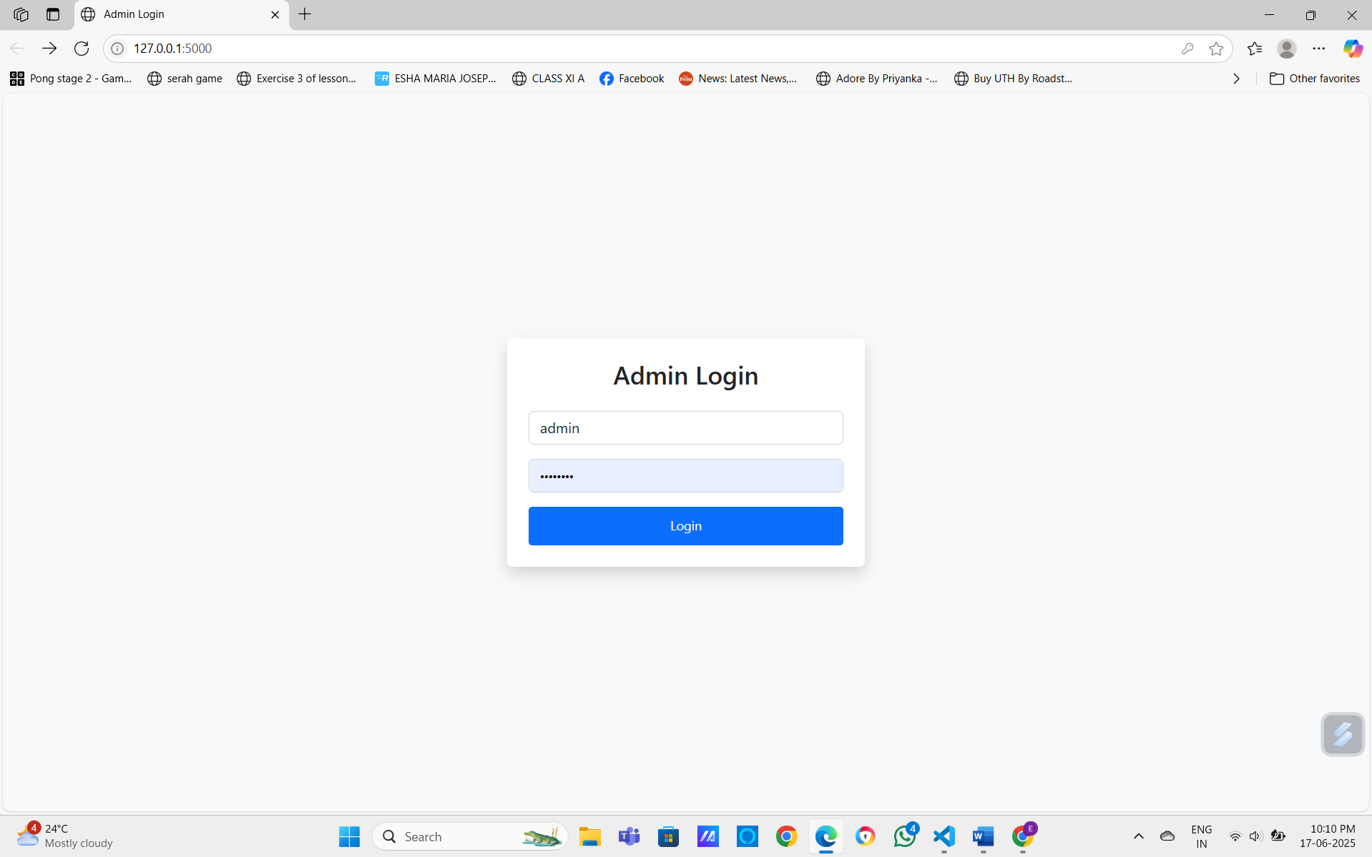

## Product Dashboard

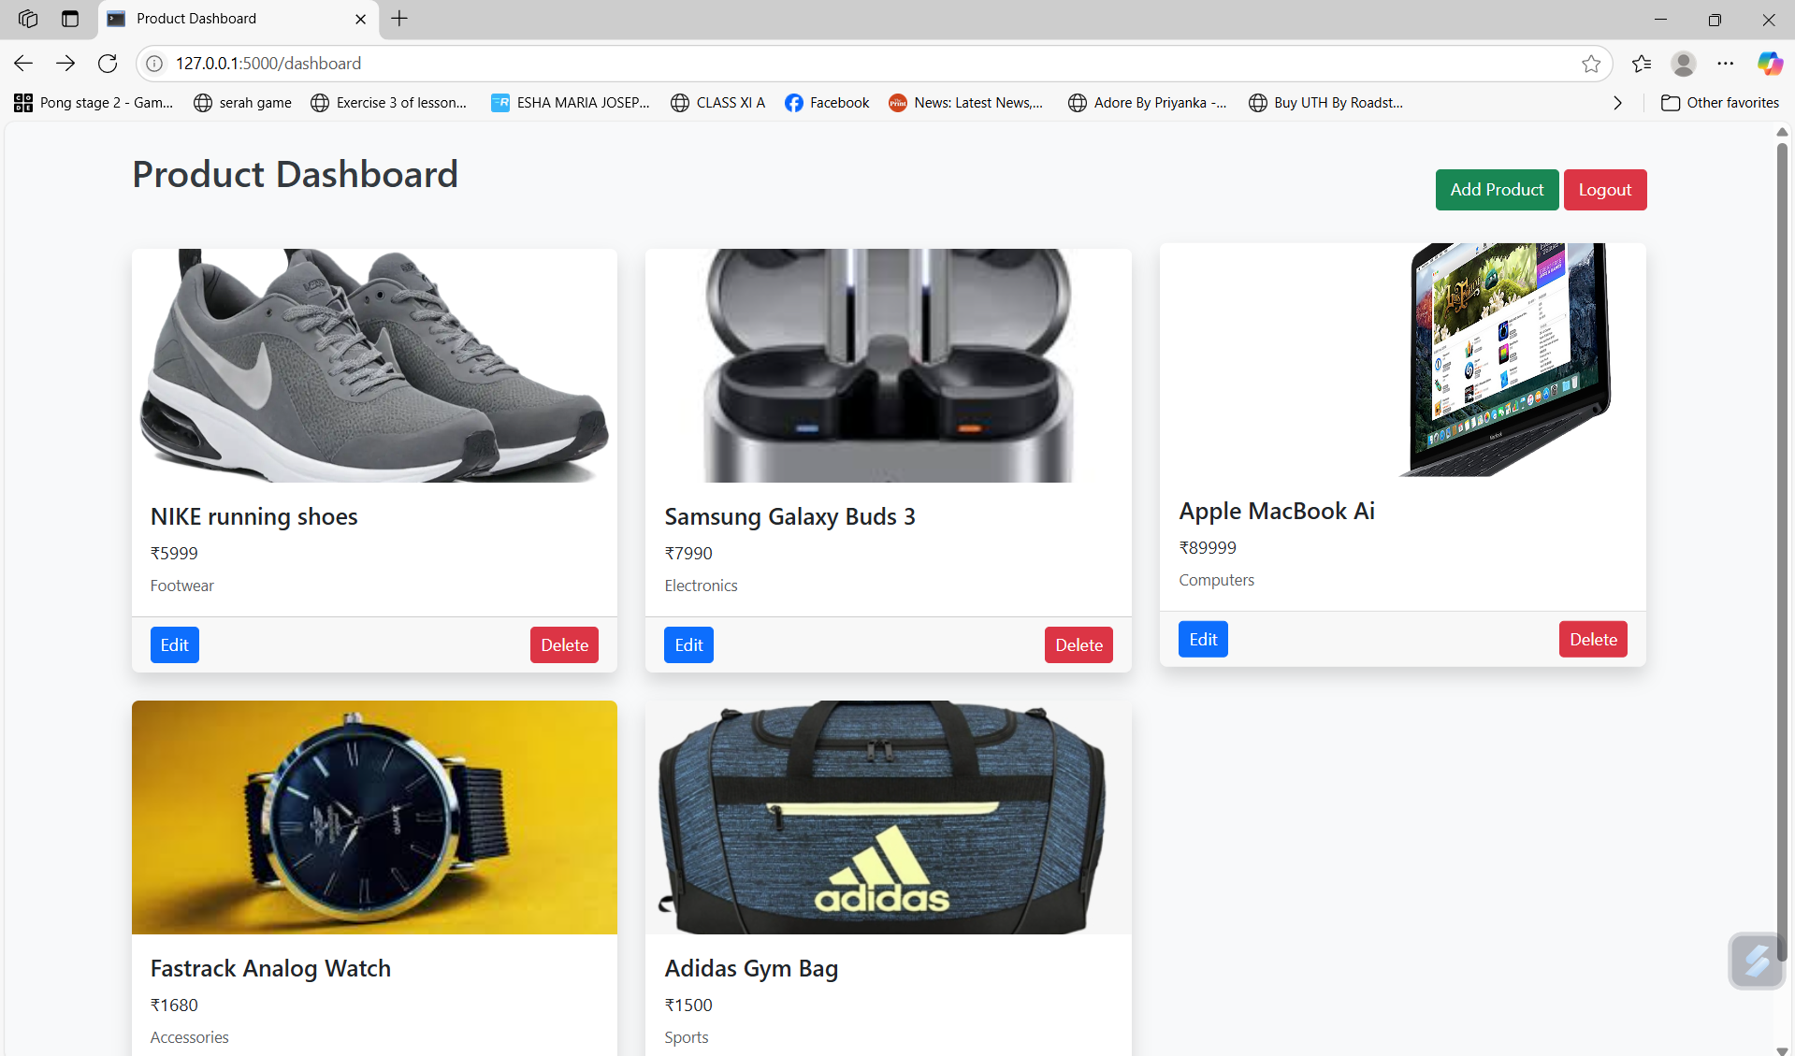

## Adding a New Product (Web Interface)

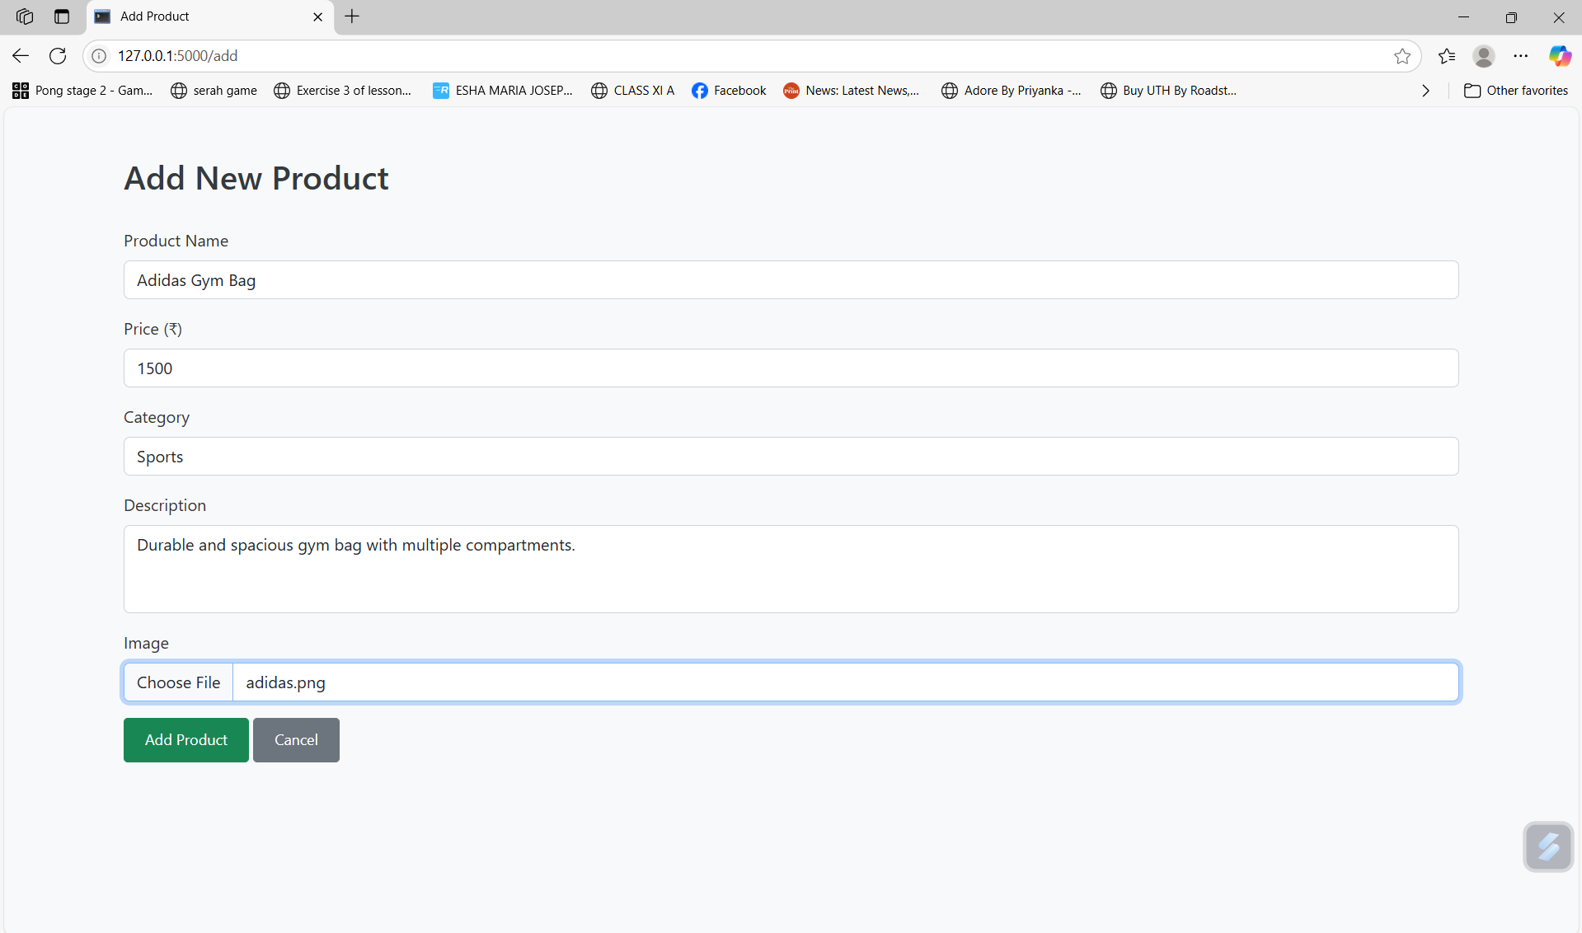

## Adding Products via MongoDB (Database Operation)

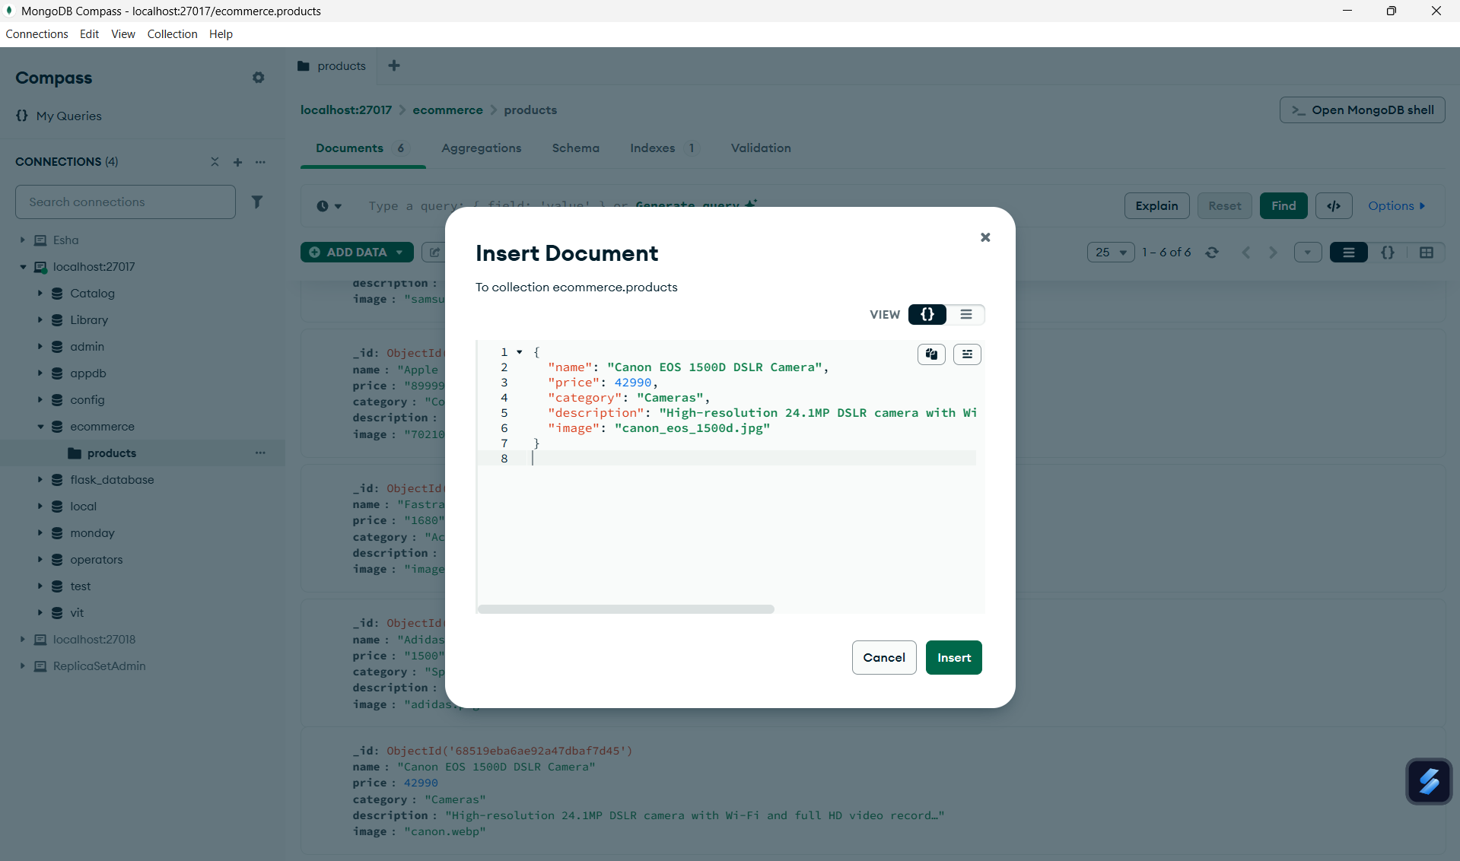

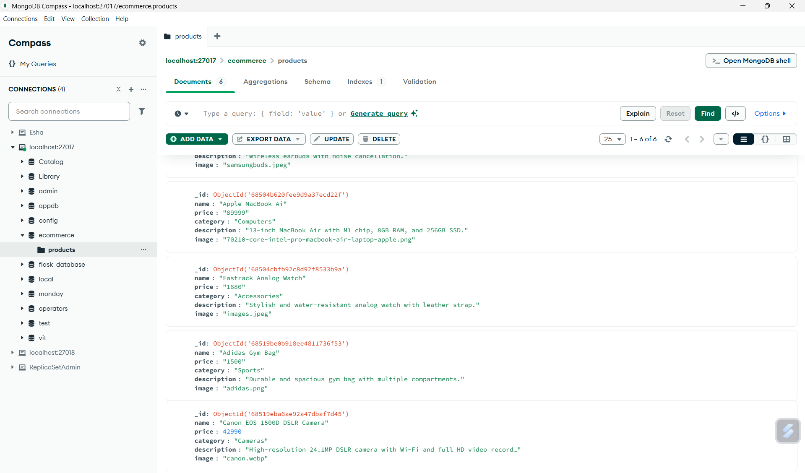

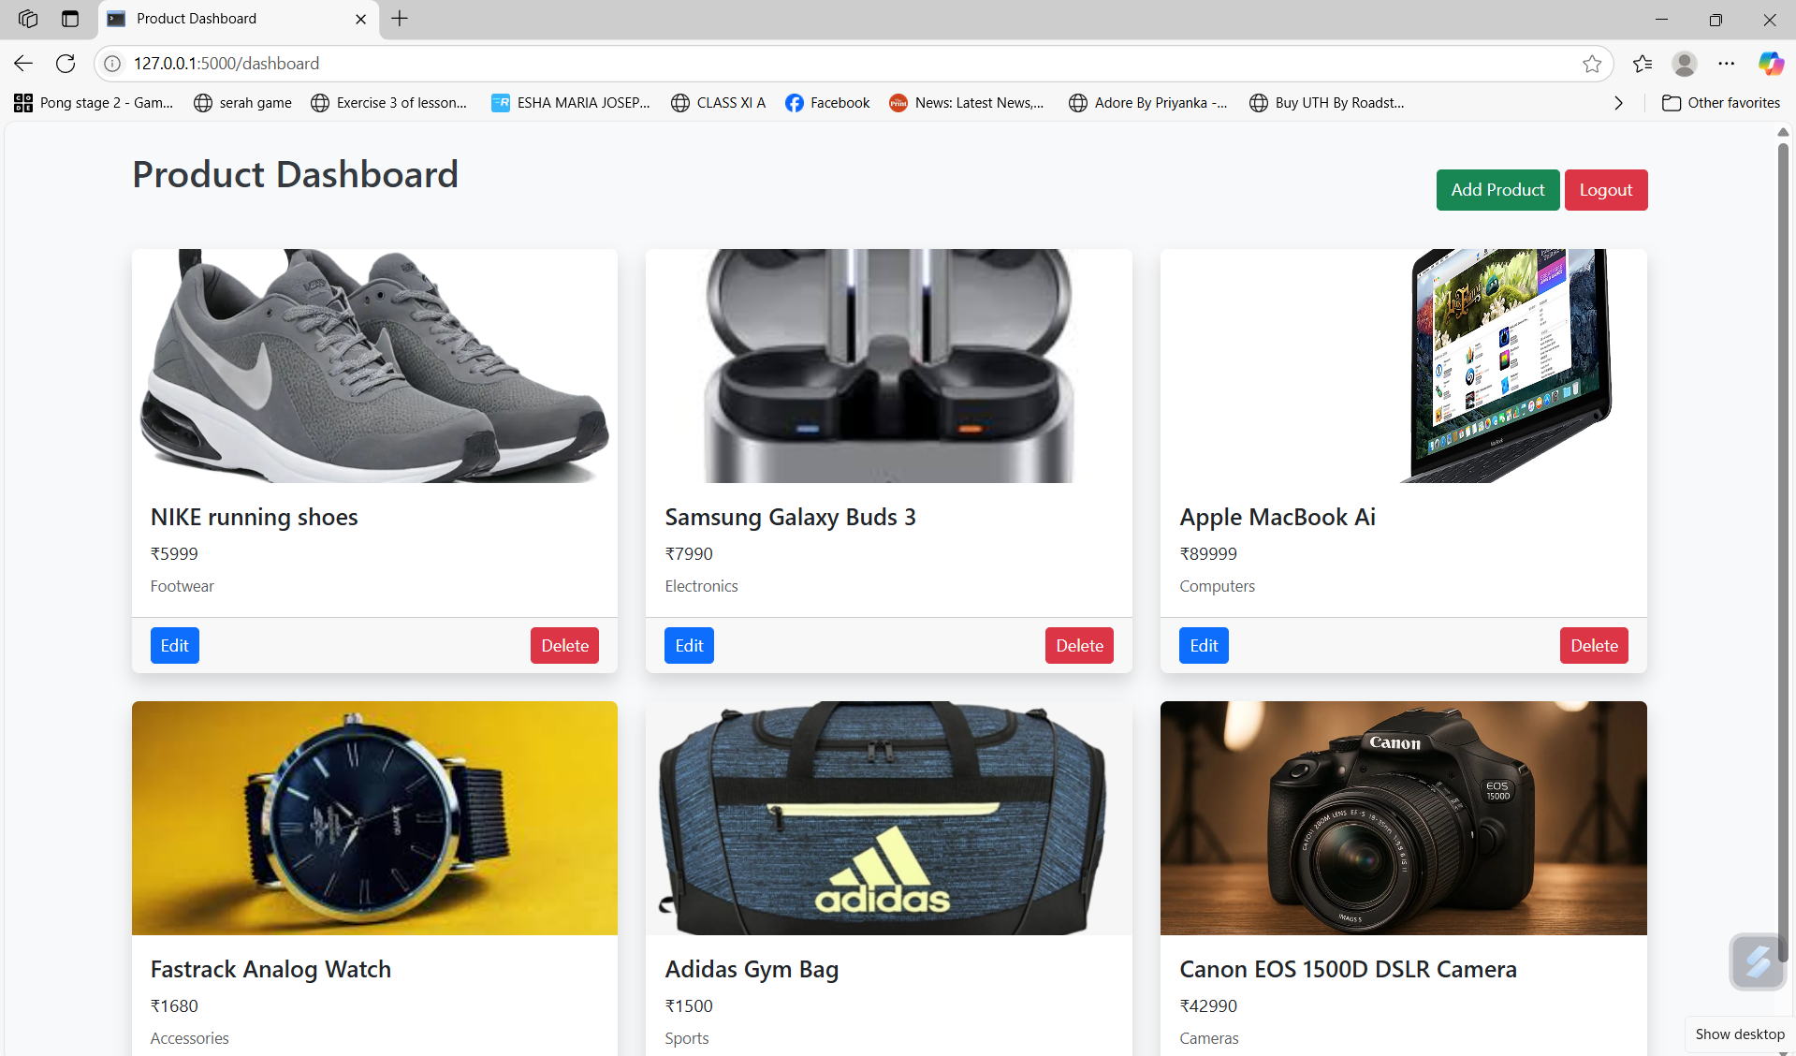

## Editing Product Details

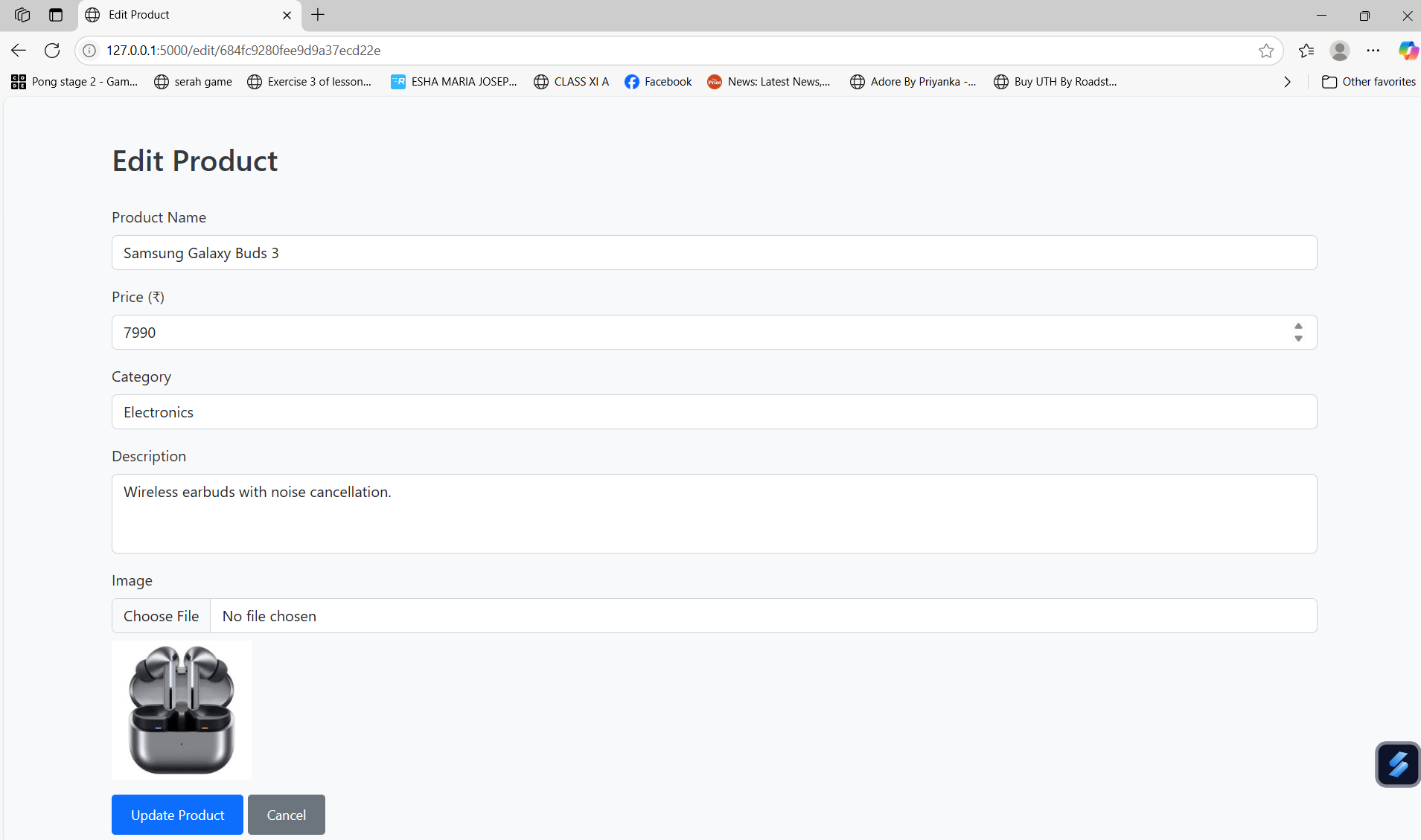

## Deleting a Product

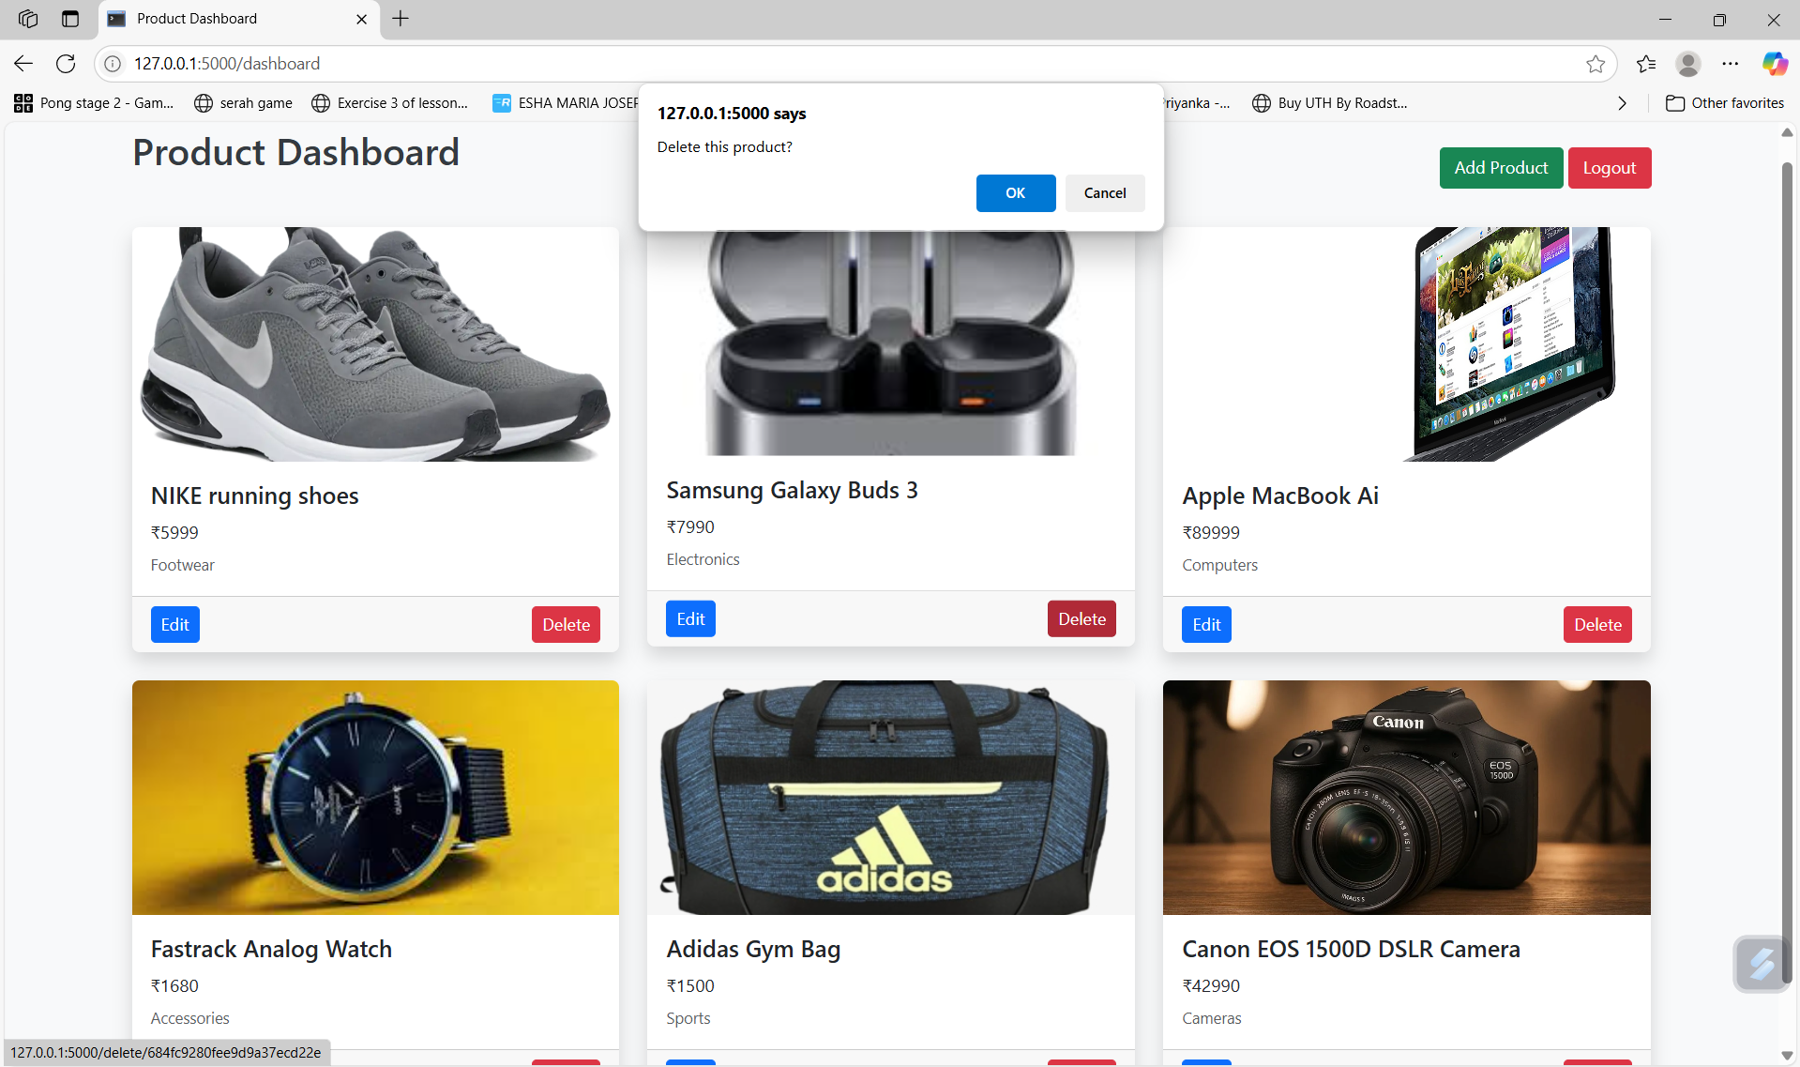

After deleting data:

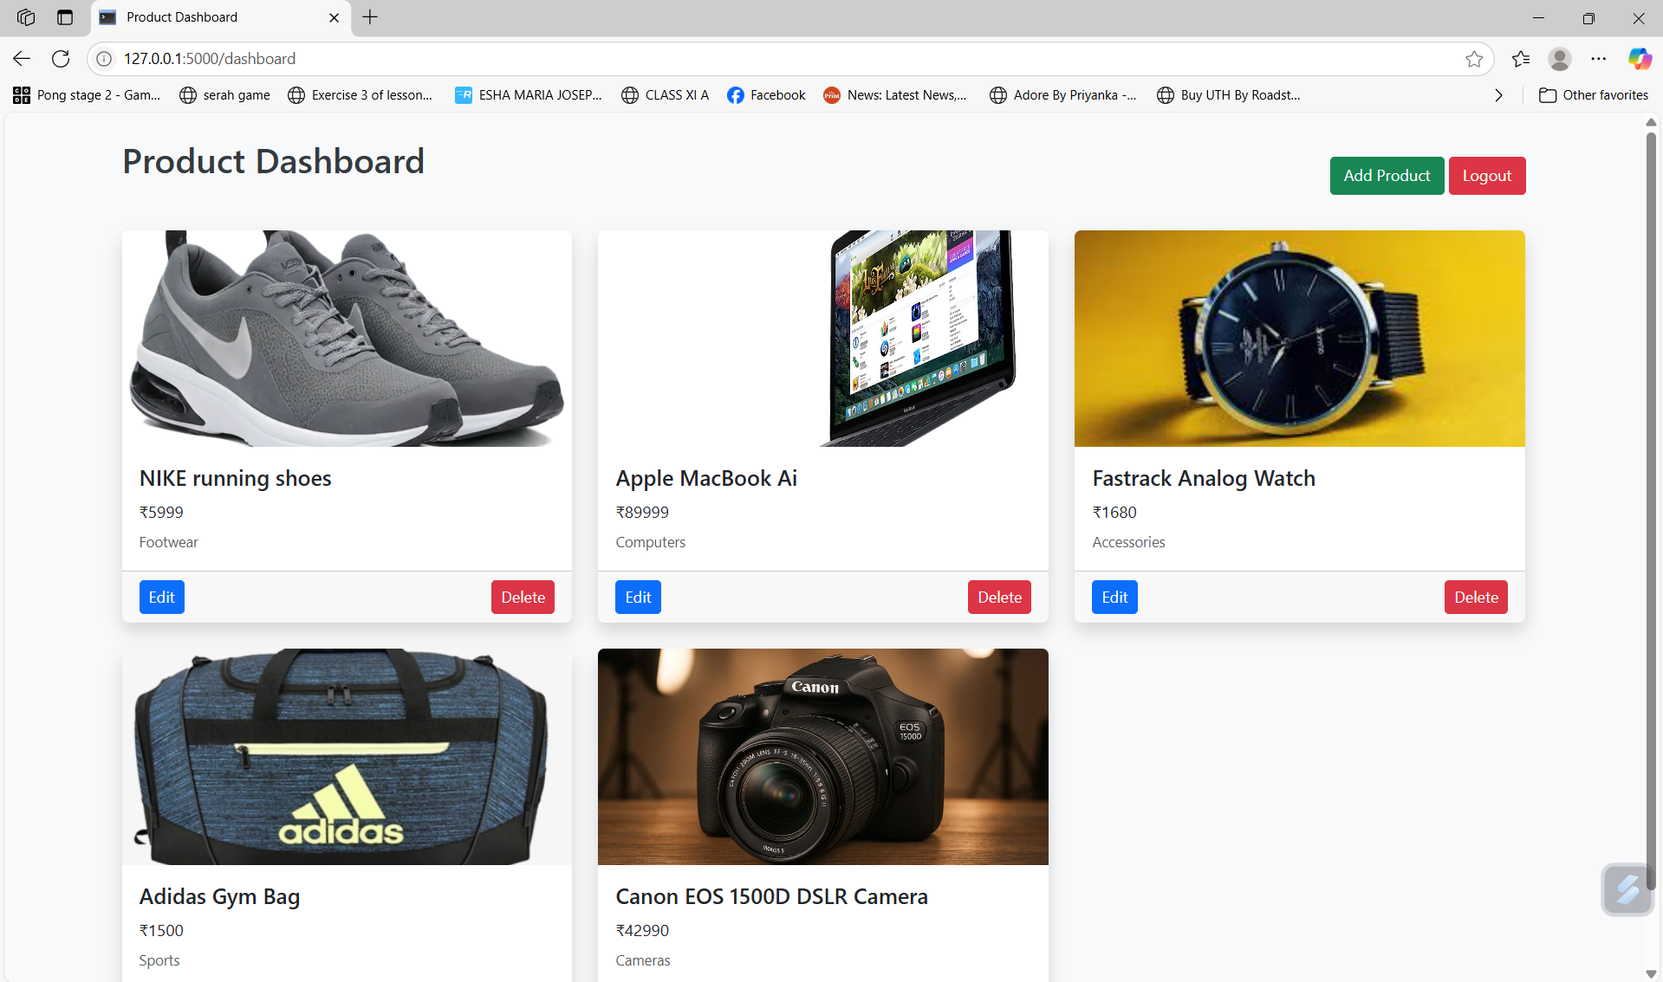

## Code Screenshots

### Backend Code (Flask):

### Styles.css:

### HTML Templates

index.html:

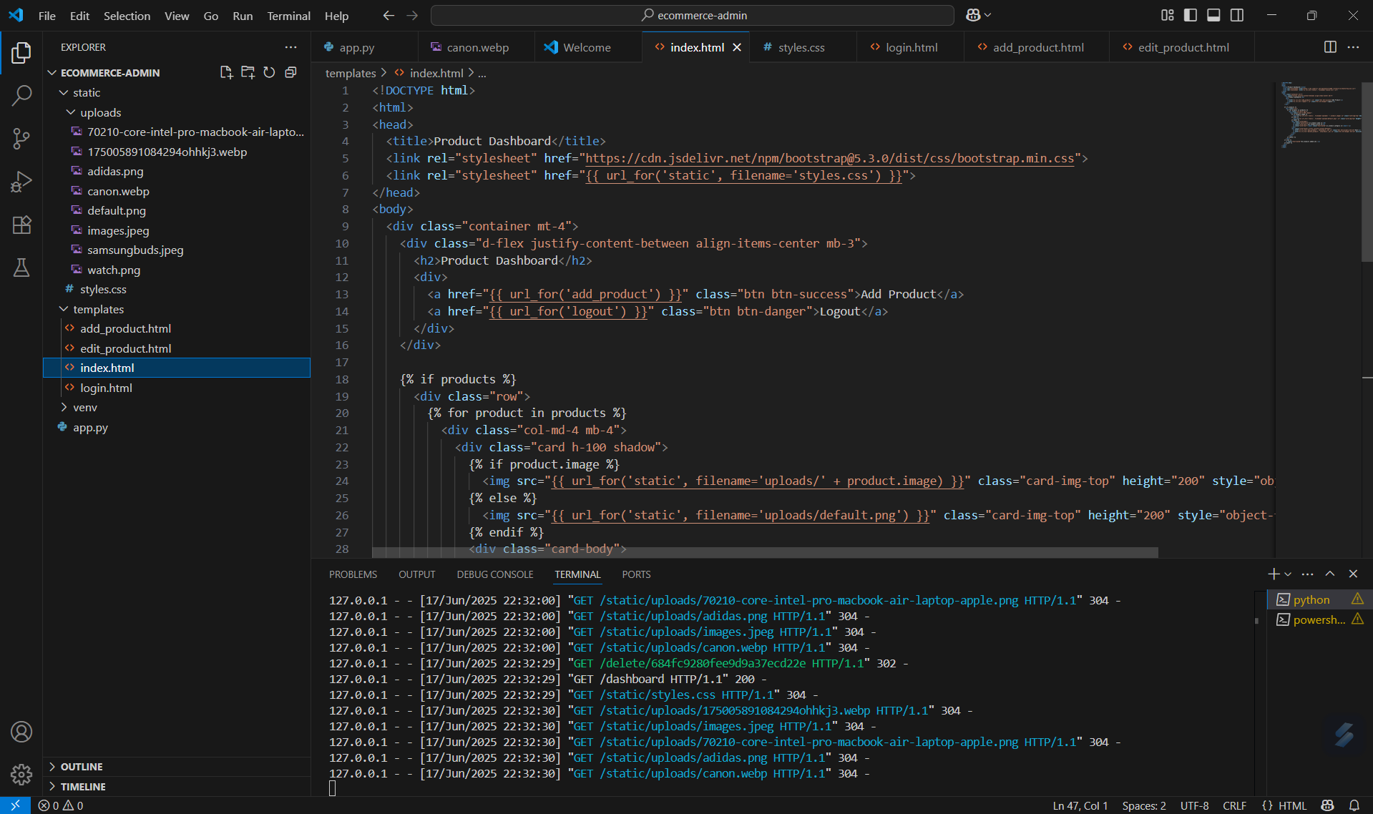

login.html:

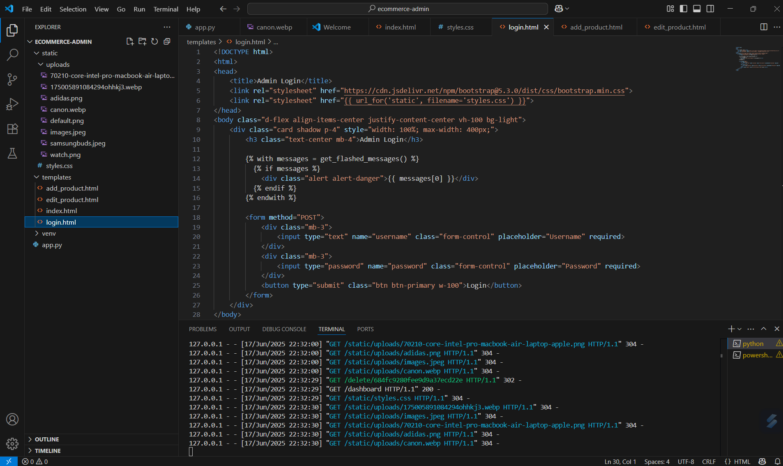

add_products.html

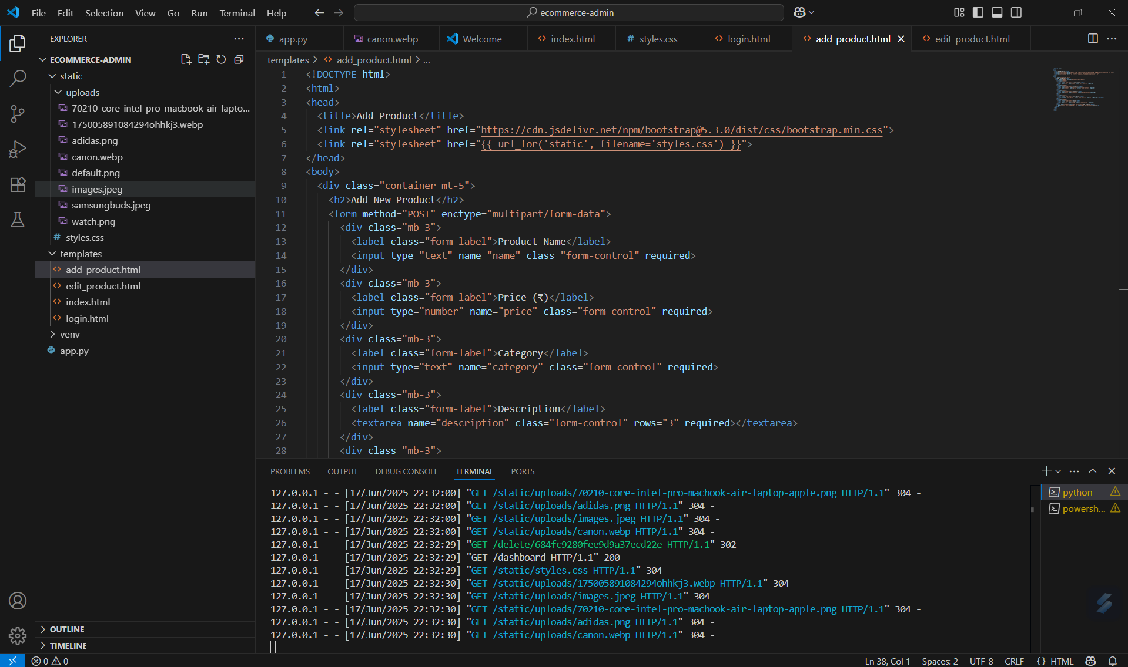

edit_products.html

